# **WIREFRAME DOCUMENTATION**

**CROP PRODUCTION IN INDIA**

|  |  |
| --- | --- |
| Written by | Rohan Deore |
| Doc version | 1.3 |
| First revised | 21/1/2024 |
| Last revised | 25/1/2024 |
| Last revised | 26/1/2024 |

Homepage:

As per the problem statement, we have divided analysis into One Story which includes three dashboards: -

1. Dashboard- Production Wise Analysis

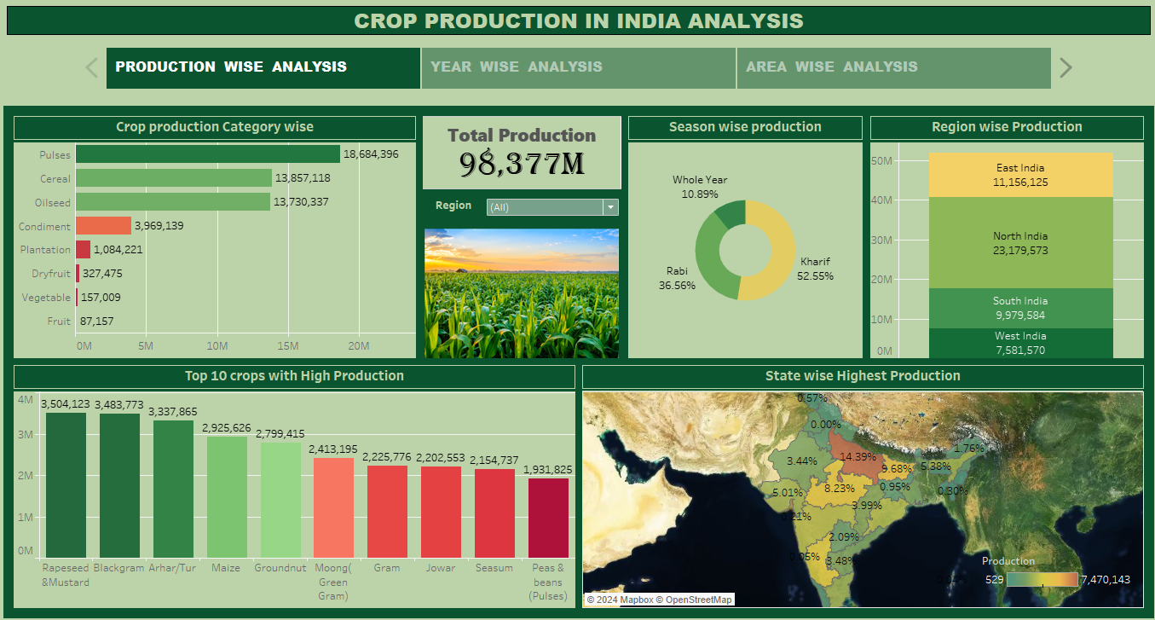

1. Dashboard – Year Wise Analysis

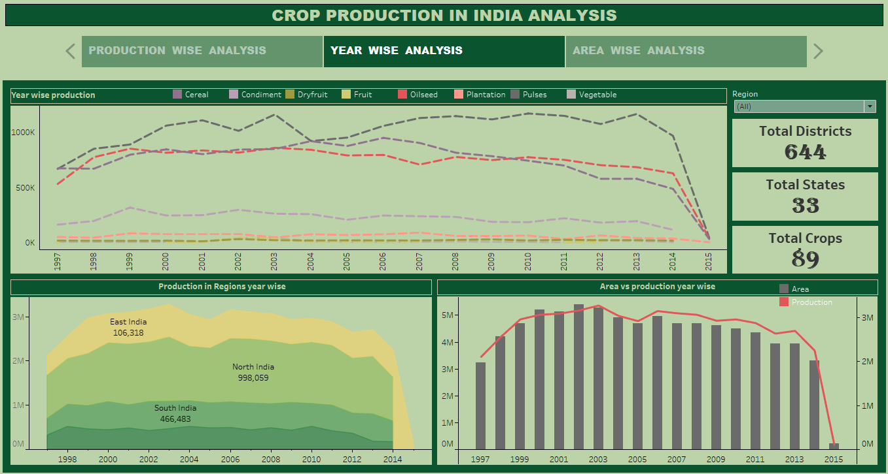

1. Dashboard:- Area Wise Analysis

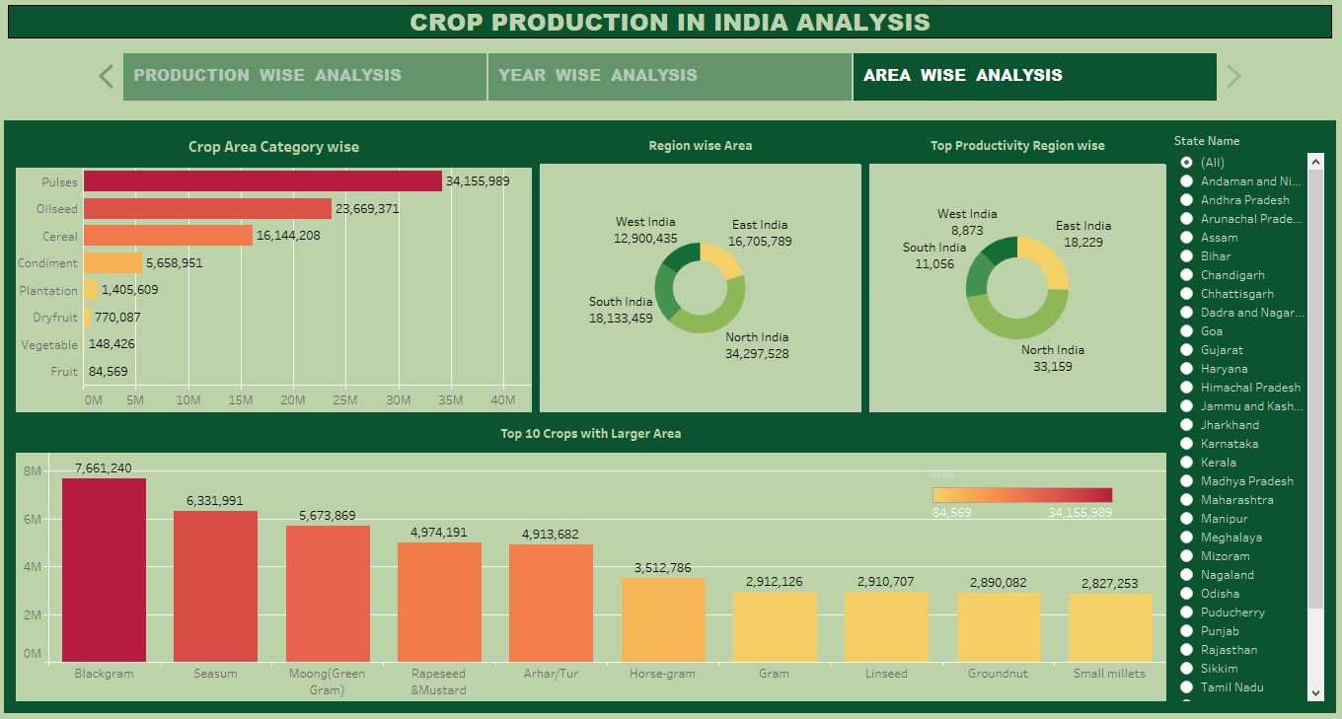

First Dashboard includes production analysis –

* Pulses, cereal, oilseeds are 3 highest crop production categories.
* Kharif season has more production followed by Rabi and Whole year.
* North India has highest production.

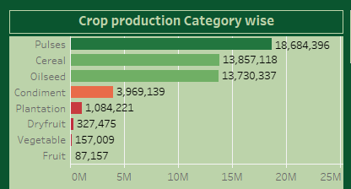

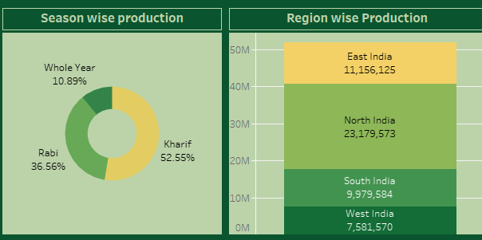

* Rapeseed & Musturd, Blackgram, Tur are 3 crops with highest production.
* Uttar Pradesh is highest production with 14.39% followed by Madhya Pradesh with 8.23%.

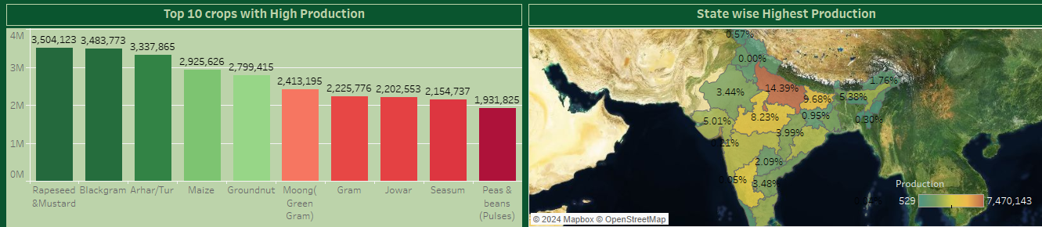

* Second Dashboard includes Year wise analysis –
* Pulses, oilseed & vegetables have highest production from 1997 to 2015.
* In 2003, 2010 & 2013 pulses have more production (above 1000k ).

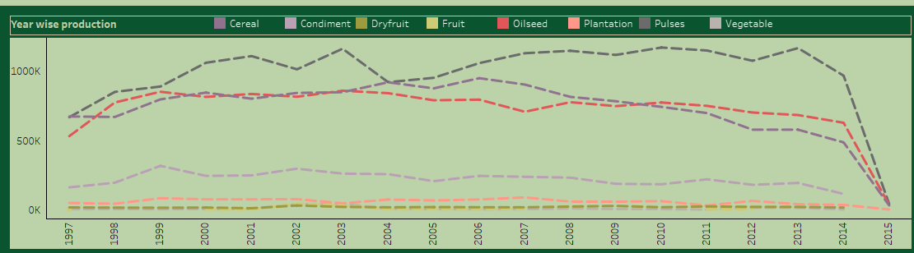

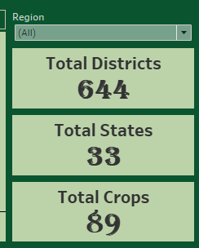

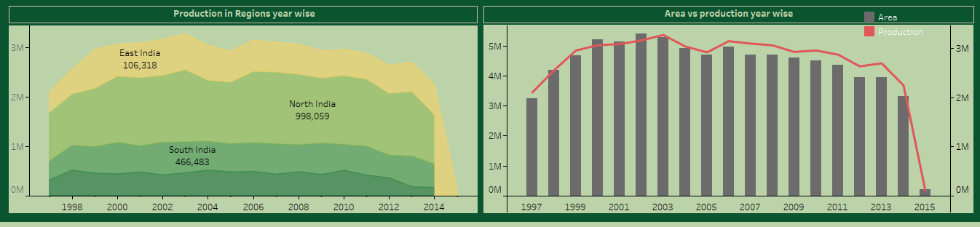

* There are total 33 states & 644 districts and 89 crops data in this dataset. You can see the KPI’s.
* North India has highest contribution in crop production over the years from 1998 to 2015.
* We can see there was rise in production from 2000 to 2003 that was peak years, then onwards we can see slightly decrease in production after 2005.
* Only years 2000, 2001 & 2002 we can see production is higher than the Area.
* We have added Filter here of Region, data will change according to regions like North India, South India etc.
* Third Dashboard includes Area wise analysis –
* Pulses, oilseed, Cereals have more area of production compare to other crops categories.

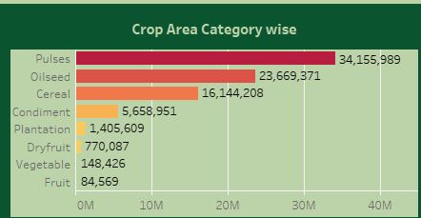

* Also North India & South India have high area of production leads to highest production regions in India.
* Here we have added State filter so we can get info and make analysis on particular state.

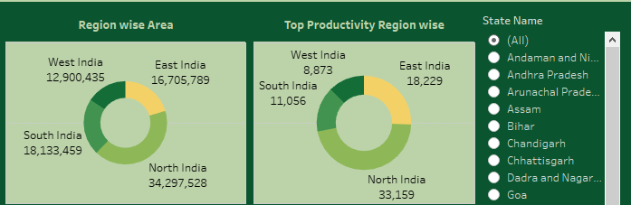

* Blackgram, Seasum, Green gram (Moong), Rapeseed & mustard, Tur are top 5 crops with Larger area.

